Experiment:5 Date:22/07/2026

The Missionaries and Cannibals Problem Using Breadth-First Search (BFS) Algorithm

AIM:
To develop a Python program to solve the Missionaries and Cannibals Problem using the Breadth-First Search (BFS) algorithm by transporting all missionaries and cannibals safely across the river without violating the constraints

Algorithm (BFS)
- Read the number of missionaries and cannibals.
- Initialize the starting state.
- Store the initial state in a queue.
- Generate all possible valid moves.
- Check whether each generated state is safe.
- Add unvisited safe states to the queue.
- Repeat until the goal state is reached.
- Display the sequence of steps.

PROGRAM:
from collections import deque
def valid(m, c):
return (m == 0 or m >= c)
def bfs(M, C):
start = (M, C, 0)
goal = (0, 0, 1)
q = deque([(start, [start])])
visited = set()
while q:
(m, c, b), path = q.popleft()
if (m, c, b) == goal:
print("\nSolution Found\n")
for i, s in enumerate(path):
print(f"Step {i}")
print("Missionaries Left :", s[0])
print("Cannibals Left :", s[1])
print("Boat Side :", "Right" if s[2] else "Left")
print()
return
if (m, c, b) in visited:
continue
visited.add((m, c, b))
moves = [(2,0),(0,2),(1,1),(1,0),(0,1)]
for dm, dc in moves:
if b == 0:
nm = m - dm
nc = c - dc
nb = 1
else:
nm = m + dm
nc = c + dc
nb = 0
if 0 <= nm <= M and 0 <= nc <= C:
if valid(nm, nc) and valid(M-nm, C-nc):
if (nm, nc, nb) not in visited:
q.append(((nm, nc, nb), path + [(nm, nc, nb)]))
print("No Solution")
M = int(input("Enter Number of Missionaries : "))
C = int(input("Enter Number of Cannibals : "))
bfs(M, C)

OUTPUT:
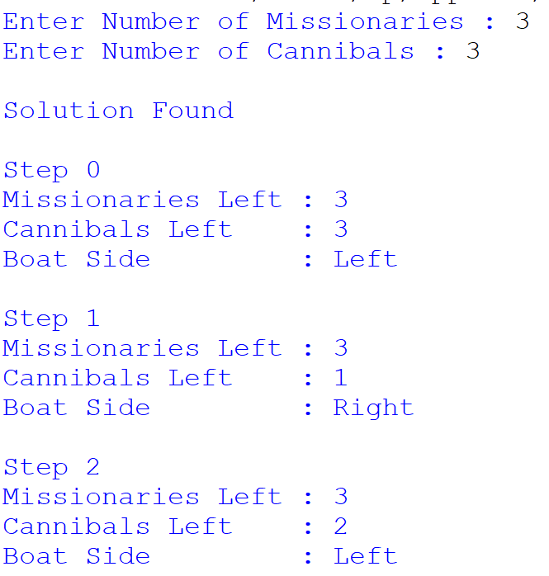
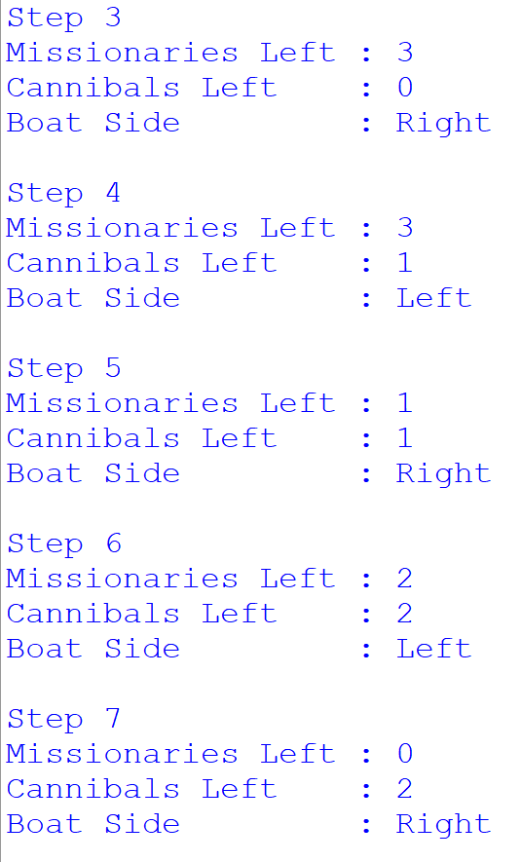

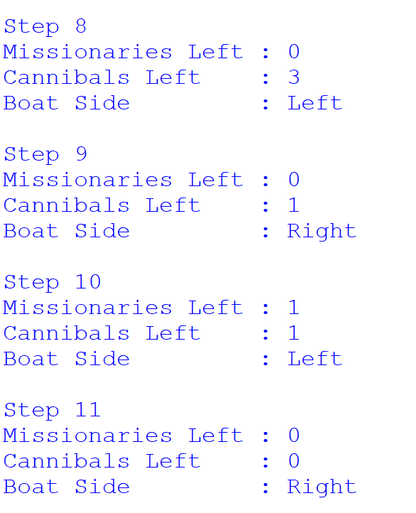

RESULT:
Thus, the Missionaries and Cannibals Problem was solved successfully using the Breadth-First Search (BFS) algorithm, and all missionaries and cannibals were safely transported across the river without violating the problem constraints.

